为让考生更好地适应机考方式的需要， 从2013年11月考试开始，对综合英语（四）课程部分试题的答题要求进行修改，现说明如下。请考生及助学教师务必注意，互相转告并做好考试准备。
1.在Part I 的Section C中添加了标红部分的要求（使用下列所有的单词和短语）。
例题：Part I. Speaking
Section C Presentation (3 minutes)

Directions:
In this part, a picture is shown on the computer screen (as is shown below).
Task:
You are required to describe the picture and then talk about the key to a successful speech at a conference by using all the following words and phrases.
You will have 1 minute to prepare and 2 minutes to do the presentation.
Your voice will be recorded into the system.
Remember to start your presentation when you hear the signal.

Now, you have 1 minute to prepare.
[Timing begins]
1 minute for your preparation→
[Timing ends]

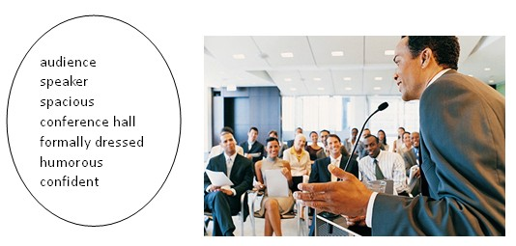

[Timing begins]
2 minutes for your presentation→
[Timing ends]
2. Part VI把汉语情景描述改为英语描述，要求考生在写作中用上所提供的英语短语。
例题：Part VI. Writing
Directions: For this part, you are supposed to write an employment ad in English in about 100 words by using all of the following phrases.
你所在的学校需要招聘两名英语教师，请你写一则招聘广告。
内容包括：
1. Changxin Middle School;
2. Employ two English teachers;
3. Under the age of 34;
4. With a master degree in English Language and Literature;
5. Those with work experience would be considered first;
6. Receive an interview with the resume;
7. Give a trial lecture in 20 minutes;
8. School address: 9 Jiaming Road, Haidian District, BJ;
9. Deadline of application: Nov. 7, 2013;
10. Contact for more details: 010-12345678.

